The main purpose of this Android app is to allow users to write a good text message on this software, and set the contact of the text message and the specified sending time. The software will automatically send the mobile phone text message to the contact's mobile phone at the specified time.

Home interface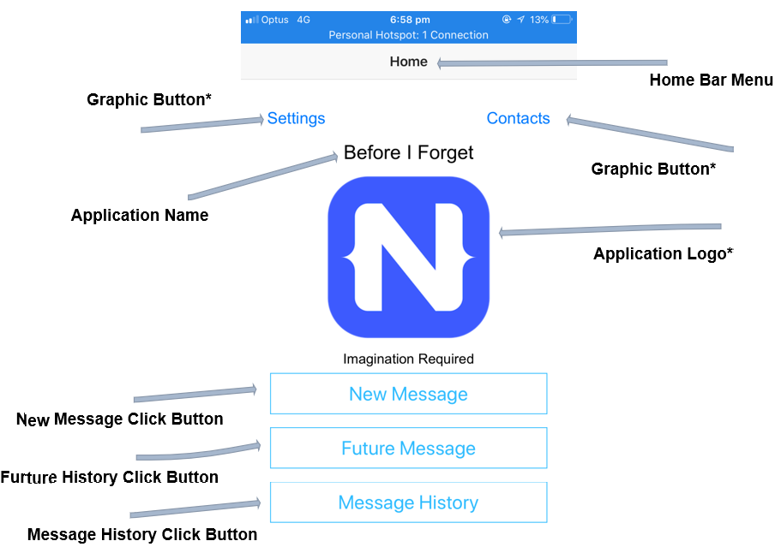

**New message interface (mms function is not needed first)**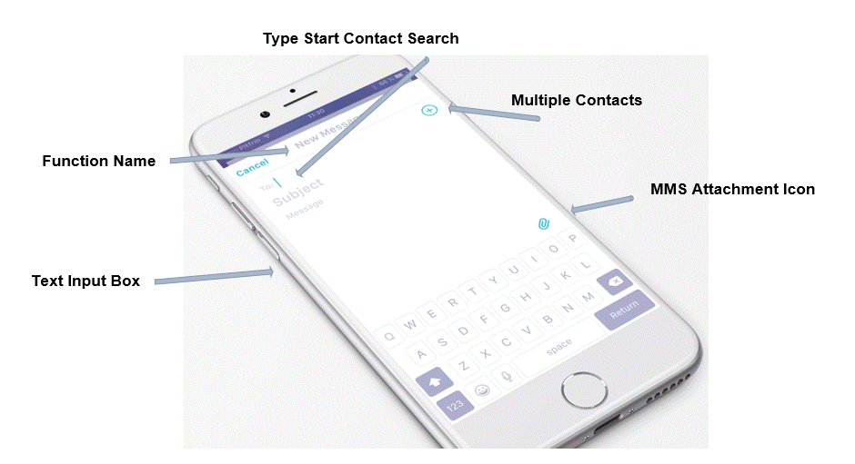

Multiple contacts interface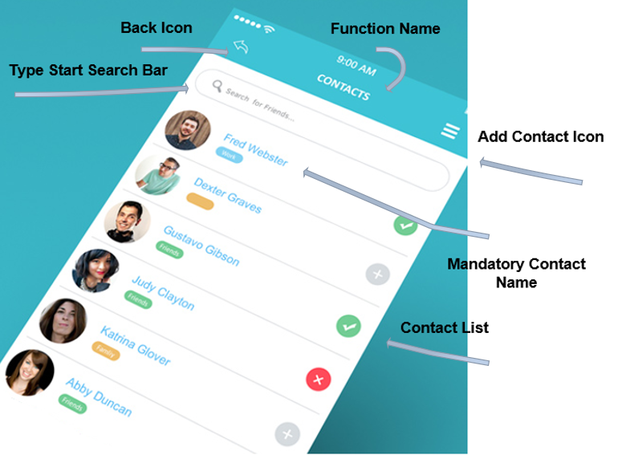

This allows multiple contacts to be selected. The selected person will be ticked behind, and the unselected display will be grayed out. You can also add new contacts at the same time. Contacts are stored in the software's own local database and are not associated with the phone's own address book.

Edit the message and press the next button to the next screen: send the time and date (this picture takes less time). The following repeat function will appear on one day before, one hour before two options (can be selected at the same time). These two options mean that the user will be prompted to have a text message to be sent one or one hour before the message is sent.

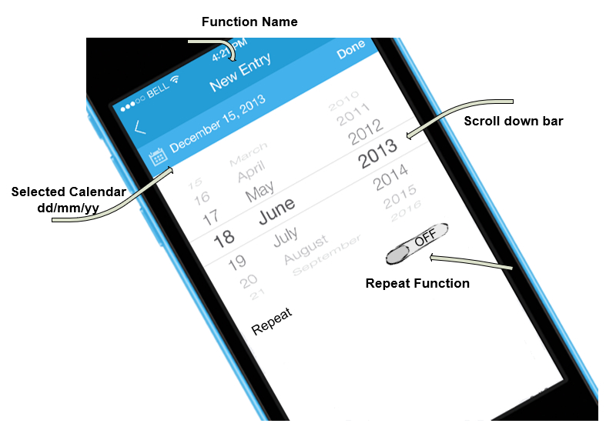

**Future message and history message interface:**

**This is to display the set SMS. When the left slide message appears, the delete button will appear. (The left slide function is not done yet.) The plus sign above is a drop-down menu that allows the user to select 4 sorts of text messages. 1) Names from a to z, 2) name from z to a, 3) time from near to far, 4) time from far to near.**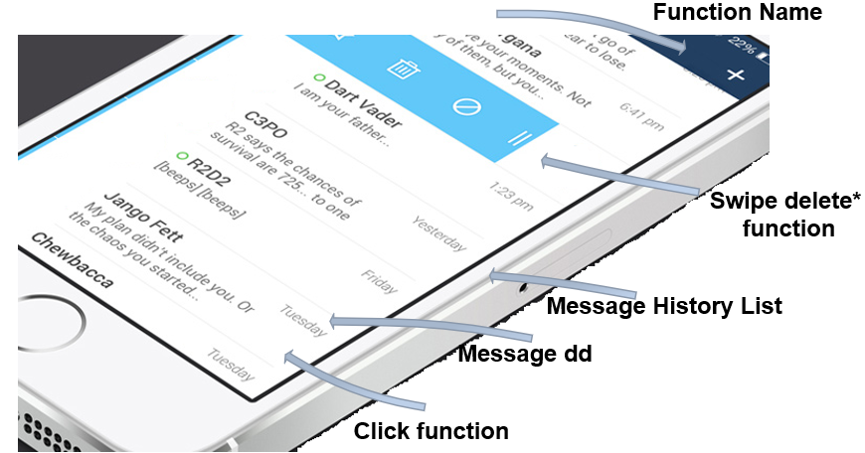

After clicking the information, it will enter the view mode. It is not editable in the view mode. It can be edited and saved when the edit button is pressed.

When the message is sent, the information in the future message will be transferred to the history message.

The History message is also the same design, but when the message is edited and saved, a new message is displayed to the future message.

**Contacts interface**

This is the interface that is accessed by clicking the contacts button on the home page. Just like the phone's address book function, you can delete, edit and add new contacts. Contact information only requires name and phone number. And you can sync the contacts in your phone's address book **to it.**